**SFO CUSTOMER DATA ANALYSIS**

Large amounts of data could sometime cause confusion and may throw one off balance if not approached with care and excitement of what mystery one stands to uncover at the end of the analysis.

**INTRODUCTION:**

It is advisable first to inspect each column / feature in the dataset, using a guide (meta data) if available

--- Recording aggregates for columns with consistent data / datatypes

* RESPNUM – 2831 total respondents
* DAY – Interviews were done on all 7 days of the week
* GATE - 72 gates
* BAREA – 7 boarding areas
* STRATA – 3 different departure periods
* PEAK – 3 categories of flight departures
* METHOD – 3 collection methods
* SAQ – 2 ways of administering interviews
* AIRLINE – 37 different airlines used by respondents
* DESTINATION – 77 different destinations
* FLIGHT – 178 different flights boarded by the respondents ranging from Flight no 24 to 8578
* DESTCODE – 91 different destinations available to flights
* DESTGEO – 9 flight destination areas
* DESTMARK – 4 market size categories
* ARRTIME – Arrival time of respondents
* Q(COLUMNS) – Questions and responses from respondents
* LANG – 4 questionnaire languages
* HOW LONG – Length of time taken from arrival to departure: average of 2 hours, 37 mins (157 mins)
* WEIGHT – 11 weight categories assigned to respondents

--- Noting columns with less meaningful or inconsistent data

* CCGID – meaning not fully captured
* RUNID – no data to know what survey areas were being referred to
* INTDATE – contains numbers rather than dates
* AIRLINE CODE – 9 major airlines and 4 low-cost carriers while the rest were unlabeled
* DEPTIME – 131 planned departure times, date ‘12/31/1899’ did not appear realistic for several reasons

**DATA CLEANSING AND PROCESSING:**

* Original Data was copied to a new workbook for cleaning and analysis
* CCIG & RUNID columns were dropped from the dataset
* INTDATE was converted into a proper date as the Day Number and Day Names seemed to tally with the 5th month of the year 2017 (May) using ‘concatenate’
* ARRTIME column was normalized into AM and PM for all rows
* Departure time was extracted into a new column excluding the included dates using ‘text to columns’

**ANALYSIS:**

* People tend to use Boarding Areas A & G way more than others with boarding area E experiencing the least usage
* Gate 4 was the mostly used gate while gate 67 was least used
* Flight departure times were fairly even between all three Strata, though a lesser number of flights departed after 5 pm (Strata 3). Lesser domestic flights also depart during peak period (8am – 1pm)
* People seem to prefer the Online method of collection
* Top 5 Airlines used by the respondents in descending order were United, United Intl, Jetblue, American, and Virgin America while bottom 5 in ascending order were Air China, Copa, Turkish Airlines, Air France and Korean Airlines

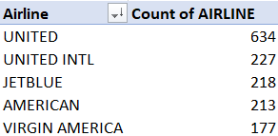 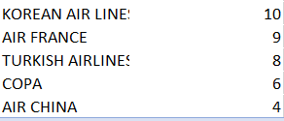

* Most flights were to the United States – West and Asia, top 5 places being Los Angeles, Seattle, Las Vegas, Chicago-O’hare and Shanghai while Australia/ New Zealand region witnessed the least flights.
* 94% of respondents were English speakers (2656 questionnaires administered in English)
* Most people travelled through SFO for Pleasure, Work, Visits to friends & relatives and for Ceremonies.
* The most common means of transport to the airport (by 2482 respondents) were Ride hailing services (Uber, Lyft), Drop Offs, Connecting from flights, Rental car center-Air Train, BART, and Drive-in and Park with most of them (110) parking in the Off-Airport parking (60) and SFO Long term parking areas (50).
* 2208 of the respondents were return users having 1645 of them flown at least twice in the last 12 months and 1880 of them have been using SFO for at least 6 years.
* Most people were fairly okay with the Arts, Food, Store, Walkways, Signs, Screens, and Roads. The Free Wi-Fi service however was ‘Outstanding’ to them. The Information Booths, Park, Air Train, LT Parking, and the Airport Rental Car Centre were not commonly used by the respondents.
* Overall, 1508 people (56% of those who rated) rated SFO Airport above average in terms of its amenities
* 1408 people did not leave comments, leaving 1423 respondents who commented. The top 5 comments from respondents in top ranked order were:

1. General positive comments/Keep up the good word/everything is great/can’t think of anything to improve (269 people)
2. Offer a wider selection of Restaurants (148 people)
3. Charging stations/plugs don’t work/add more plugs/easier to find (115 people)
4. Too expensive/reduce prices/offer cheaper options/offer free coffee/food (77 people)
5. Better Wi-Fi/could not connect/keep getting dropped/other issues with Wi-Fi/make info about Wi-Fi more available (68 people)

* Most of the respondents indicated that the Boarding, Airport Restaurants and Restrooms were clean while they had never used the Airtrain and Airport Car Rental Services area.
* Majority of respondents found the Overall cleanliness of the Airport above average.
* Only 186 people commented about the cleanliness, the top 3 comments were:

1. Airport is very clean/well maintained/keep up the good work/other positive comment related to cleanliness (115 people), an equivalent of 62% of people who commented
2. Bathrooms are dirty/not maintained (30 people)
3. Boarding areas/seating dirty/stained/litter on floor (14 people)

* On an average, people feel extremely safe at SFO (1424 people). Their top 3 comments were:

1. Just feel safe/don’t see anything to worry about/gut feeling (264 people)
2. There are a lot of security/officers/airport staff who are walking around/alert/effective/staff is friendly/professional (260 people)
3. Security procedures/equipment/cameras are visible/effective (115 people)

* Only 34% of the respondents used the TSA Precheck, and their top 3 comments were:

1. Easier/faster/less hassle/great/a godsend/general positive comment (325 people)
2. Did not have to take off shoes/belt/unload laptop, etc. (67 people)
3. Line too slow/No faster than regular TSA line (51 people)

* Most of the respondents were at the airport from San Francisco (971 people = 34%) and connecting flights (580 people = 20%). Majority of the people also indicated they did not encounter problems and that it was easy getting to the airport, finding their way around SFO and passing through security/ screening.
* Top 3 comments from those who encountered problems were:

1. Signs/info boards provided confusing/incomplete information
2. Difficulty finding gate/terminal
3. Security took too long/too confusing/staff rude

* 75% of respondents are very likely to promote / recommend SFO to people
* All other California and Western Union region seemed to be home to a large number of the respondents (614 people)
* SFO may have more users between the ages of 25 – 34 than other age bands
* There were fairly about same number of males as female respondents who used the airport with less than 0.5% attributed to other genders.
* Most of the female respondents earned about $50k - $100k as income while most male respondents earned above $150k
* Majority of the respondents fly less than 100k miles per year
* Majority of the respondents have used neither San Jose nor Oakland Airports in the last 2 years

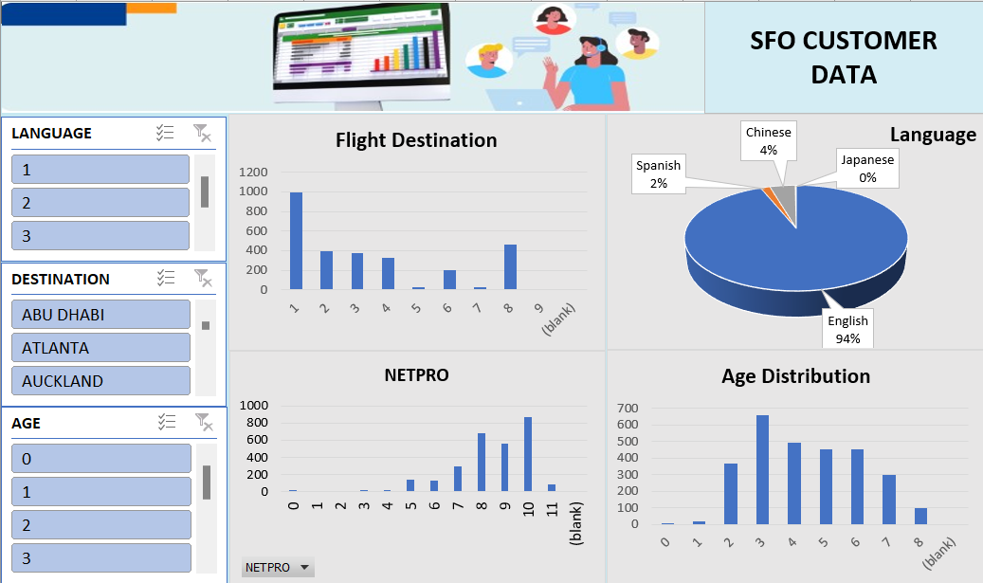

**Link to the Analysis Spreadsheet (including the Dashboard):** [**https://github.com/Implilekan/Implilekan/blob/master/SFO%20Customer%20Data.xlsx**](https://github.com/Implilekan/Implilekan/blob/master/SFO%20Customer%20Data.xlsx)

**CONCLUSION AND RECOMMENDATION:**

SFO’s services, amenities and facilities seem satisfactory to a large number of its users, the standard should be upheld even as some of the concerns observed by some sets of users are addressed as recommended below:

1. The Information booth needs more visibility where users could be more informed about SFOs services and offerings. Could the signage be modified? Could the booths me moved to different locations?
2. Rather than the Airport Rental Car Centre which was not popularly used, SFO could consider a business partnership with popular Ride Hailing service providers to help promote SFO and make navigation to the Airport easier for people.
3. Incentives/ Loyalty rewards should be offered to long term users in terms of discounted food prices, premium/passworded free Wi-Fi to decongest traffic on the general one and better service to loyal users.
4. A survey should be done and centered around restaurants and their offerings and suggestion from users on what offerings they desire from the Airport Restaurants.
5. Closer attention should be paid to all of the bathrooms, boarding areas and charging stations to ensure proper maintenance.
6. Staff attitude should be monitored closely and the signages or information boards checked for corrections/modifications as required.
7. Online advertisement should be given more priority seeing that people prefer the Online method of collection and a live help/chat made available on there to assist people right from their homes, through the airports up till departures.

Thank you

Olalekan Olujobi